Knowledge transfer presentation
Yuanhao(Jim) Liu
University Of Waterloo
React frontend
Nodejs backend
MongoDB database

Code related account
Balance Sheet Account: BSA
Functional Center Account: FCA
Secondary Financial Account: SFA
Secondary Statistical Account: SSA

Business Admin: test8@test.com
Approver: linda_approver@test.com
Submitter: linda_submitter@test.com

Org and Org Group is N:1 relationship.
Template Package defines a relationship
Between N templates and N template type programs for better batch publishment

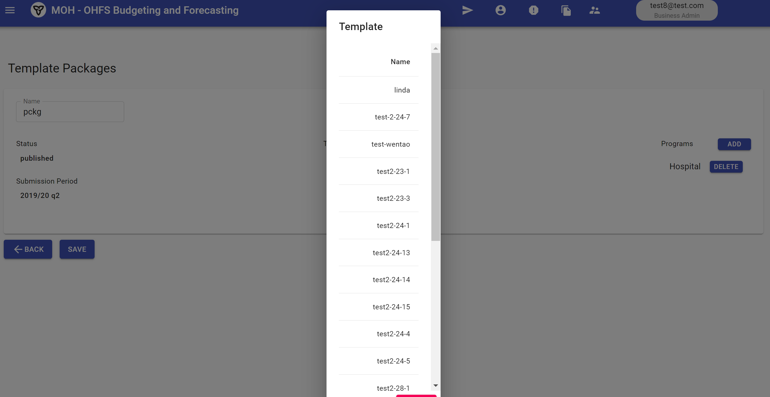
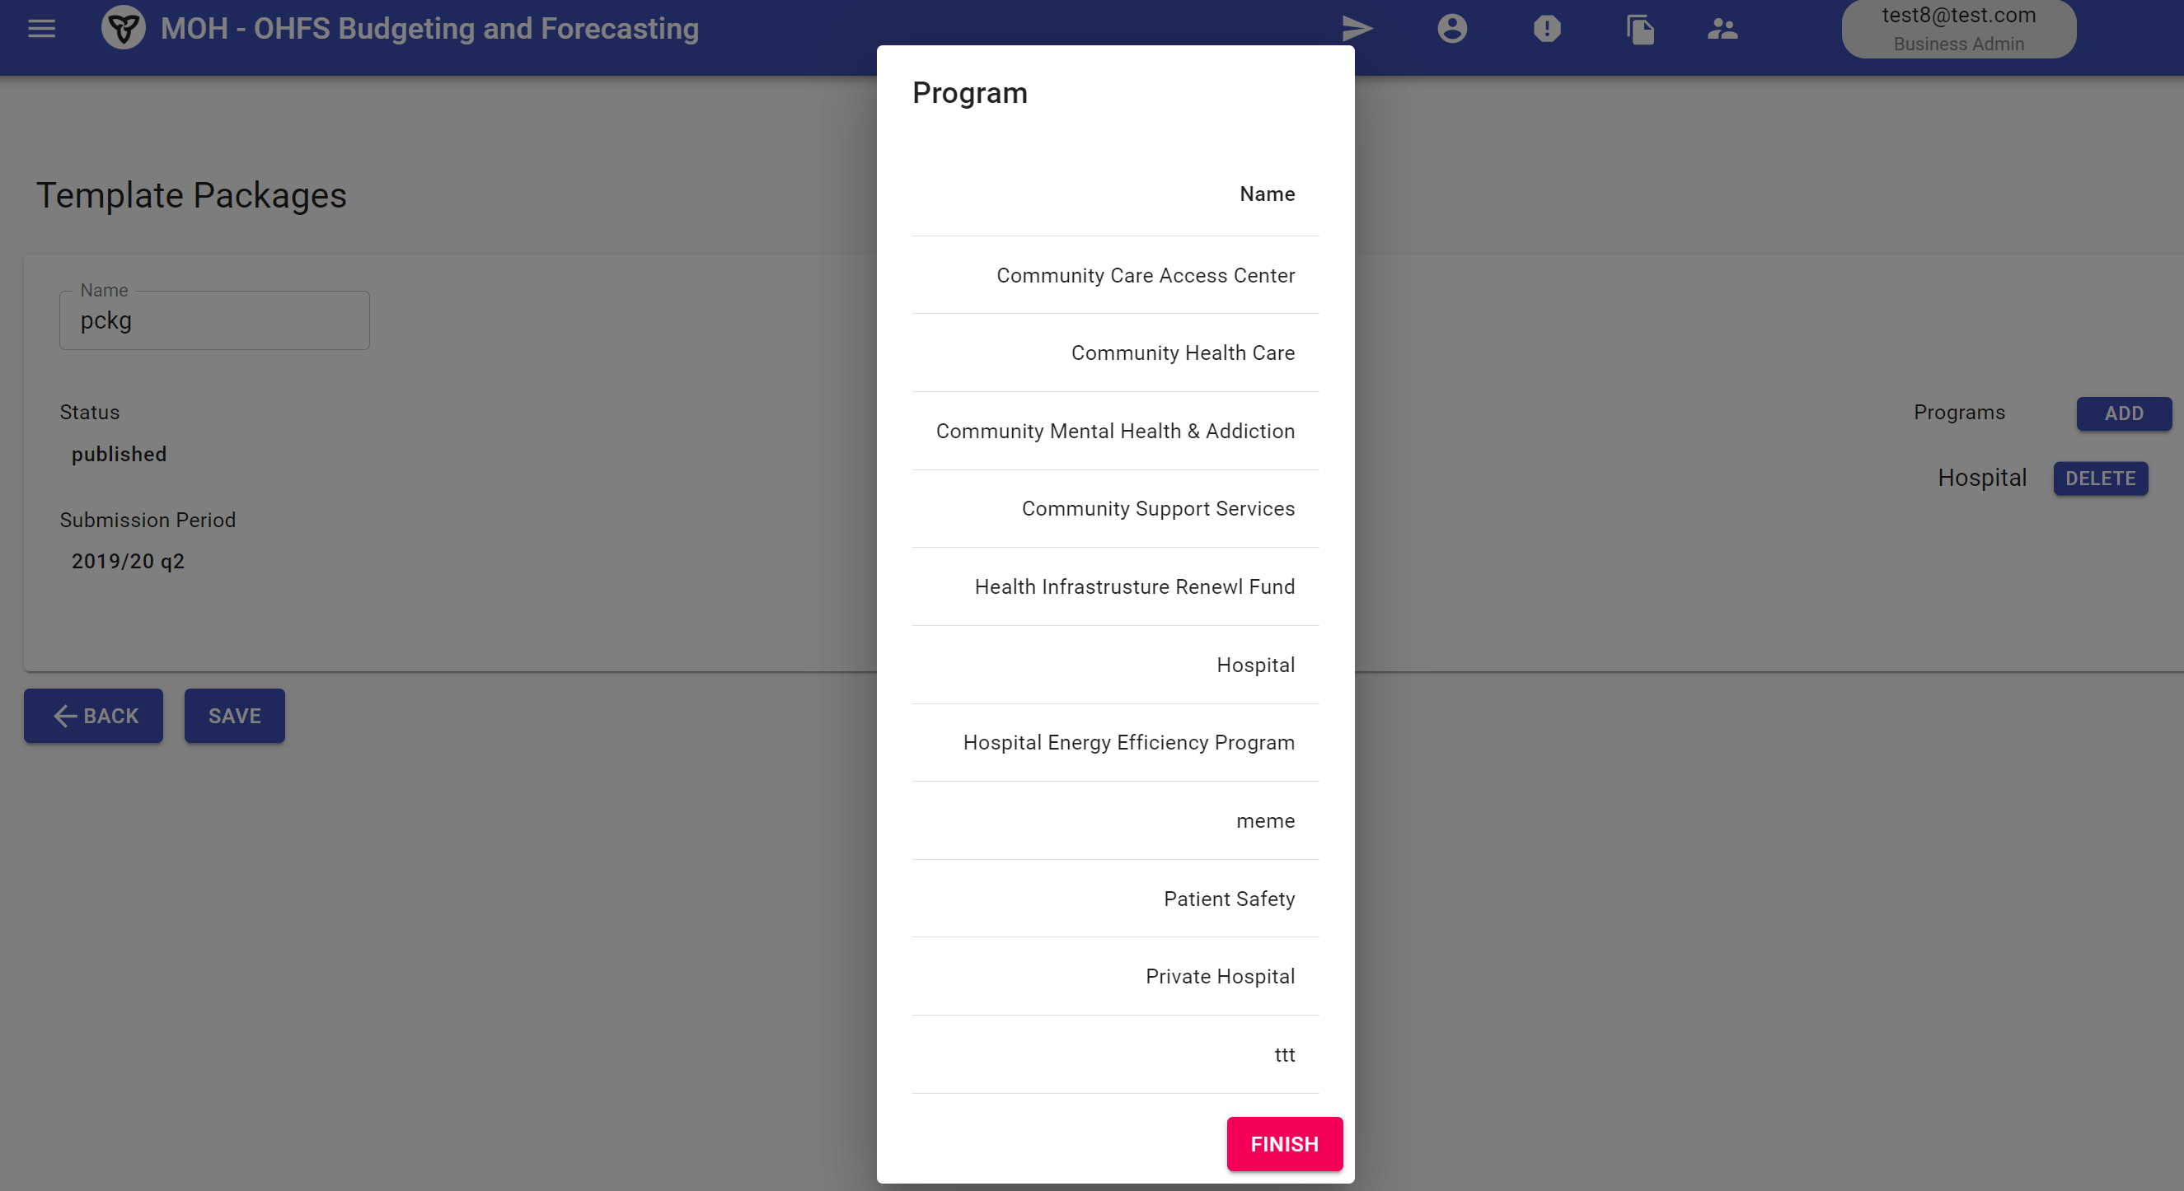

Database link code:
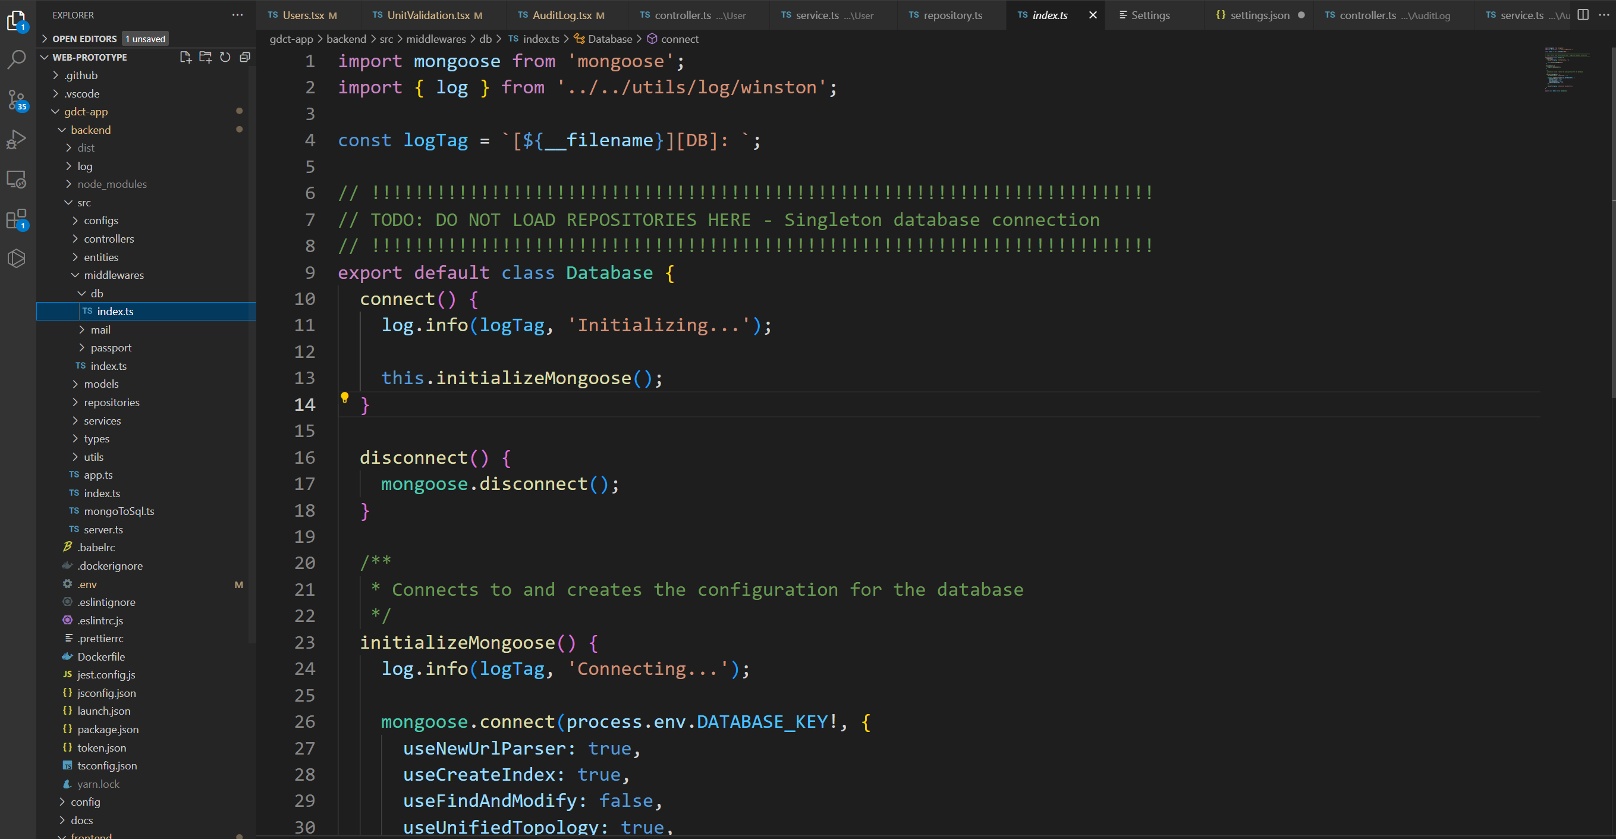

Source:
TEAMS/Sam Unit/Files/Generic Data Collection Project/System Design/Design.docx

